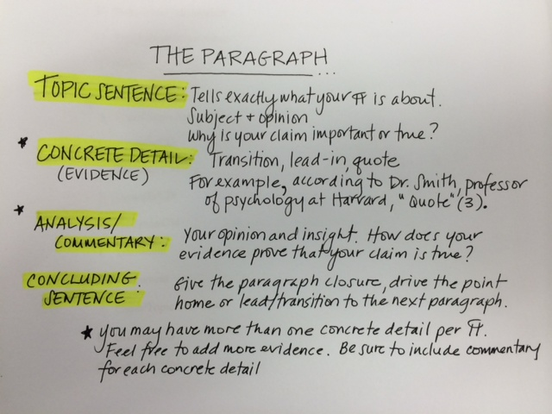

PARAGRAPH STRUCTURE
1. Topic Sentence:
2. Concrete detail/evidence #1: Use a transition and lead-in
For example, for instance,
3. Commentary/Analysis: Comment on your evidence.
4. Commentary/Analysis: says more about your evidence.
5. Concrete detail/evidence #2: Use a transition and lead-in
Furthermore, in addition, moreover, similarly,
6. Commentary/Analysis: comment on your evidence.
7. Commentary/Analysis: says more about your evidence.
8. Concluding sentence: Wraps up the paragraph.

